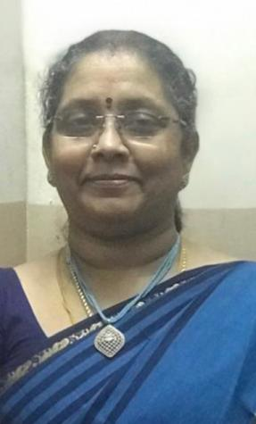

Dr..S.Jayalakshmi
MBBS, D.C.H, M.D. (Int. Med), D.M. (Nephro)
Consultant Nephrologist
Reg No 47035

Dr S.Jayalakshmi is the renowned Nephrologist currently consulting at CURI Hospital, Chennai has got 20 plus years of experience in this field. She has attained MBBS, DCH from Madras University. She also has attained MD(Internal Medicine) and DM ( Nephrology) from Tamilnadu Dr MGR Medical University.

She has a very kind nature and her vision is to provide comprehensive healthcare, clinical excellence and enriching lives every minute, every day and to create a world-class integrated healthcare delivery system in India, entailing the finest medical skills combined with compassionate patient care.

Her Areas of Interest are Hypertension, Hemodialysis, Preventive Nephrology and Onco-Nephrology

